Digital story toolkit:
Using Stories to Improve Quality

Contents
1. This Toolkit 4
2. What is a story? 4
3. What is a digital story? 5
4. Why gather and use digital stories? 5
4.1 Using stories to support and monitor service improvements 5
5. Who tells the stories and who records them? 6
6. When to record the stories? 6
7. Thoughts on preparation 7
8. Safeguarding 7
9 . Consent 7
10. Support for the storyteller, facilitator, and listener 8
11. How to become a story facilitator 8
12. Gathering the story with the storyteller 9
13. How to help someone prepare to tell their story 9
14. Starting to record 10
14.1 Recording with someone on Teams 10
14.2 Editing the audio and creating a video 10
14.3 Filming 10
14.4 WAST and CIVICA portals 10
15. After the story has been created 11
15.1 Learning from stories and action plans 11
16. Presenting and sharing stories 11
17. Closing the loop with the storyteller 12
18. Final thoughts 12
18.1 Protected time for staff 12
18.2 Number of stories 12
18.3 Quality control and support 12
19. Appendices 13
1. Equipment for Digital Storytelling Telling 14
2. Story request & submission form 15
3. Checklist for facilitating a story 17
4. A process flow for story facilitators 18
5. Storyteller information sheet 19
6. Storyteller consent form 20
7. Storyteller accessible consent form 21
8. Guidelines for referring to patients in staff stories 24
9. Action plan for digital stories 25
10. Story graph & story board for helping people plan & shape stories 26

1. This Toolkit
In September 2021 it was agreed by the Welsh Directors of Nursing that digital storytelling would form a keyway of capturing feedback and learning to improve our services. This toolkit covers the methodology and information needed by everyone who is digitally recording stories, related to individual feedback and personal experiences of any of the health services provided via NHS Wales.
The term stories relates to people’s first-hand experience of health care. Stories should always be in the first person and informed by good storytelling practice. Training and training videos are available for staff who want to record people’s stories. Please see click here for more information. The training videos are under development and will be disseminated through the network once they are completed.
The toolkit does not cover all digitally recorded stories, for example: those made by communications teams or those made for education or service promotion, or stories for qualitative research or Arts projects or stories recorded as part of therapy. Whilst these are not covered by this toolkit, the principles and best practice described here would be useful for all making digital recordings of any kind within the NHS.
The terms ‘people’ and ‘communities’ encompasses all individuals and groups who make up our local and national population. It includes patients, their families, service users, carers, and staff. The terms can also include stakeholders and partner organisations.
This toolkit has been developed in partnership with all NHS Wales organisations. It is for use across all programmes, services, and functions provided under the NHS Wales umbrella where quality and improvement are a priority.
This toolkit appendices provide further information and templates for:
- Equipment for Digital Story Telling
- Story request and submission form
- A checklist for story facilitators
- A process flow for story facilitators
- A storyteller information sheet
- A storyteller consent form
- Reduced capacity consent form
- Specific guidance for staff stories
- Action plan for digital stories
- Story graph and story board for helping people plan and shape stories

Please check with your Patient Experience Manager for information relating to specific practice in your organisation.

2. What is a story?
First person stories are engaging to listen to, they are memorable, and build empathy in the listener.
Stories are not case studies or verbatim telling of experiences. Stories have different shapes, and some understanding of story shapes will help a person tell a story that draws the listener in and keeps them focused on the story all the way through to a clear ending.
At the simplest level, stories have a beginning, a middle and an ending. They start when something happens to disrupt normal life. The protagonist (in first person stories this is the person who is telling the story) goes on a journey with difficulties that need overcoming. There may be helpers along the way and the protagonist is changed through the experience. Where the story ends may depend on when you meet the person on their journey.
It is essential that people facilitating storytelling understand some story theory. The more the facilitator understands how to construct a story, the more they will be able to help someone tell a story well. It is these well told stories that will have the impact of improving services.

3. What is a digital story?
This toolkit covers all digitally recorded stories related to individual feedback and personal experiences of any of the health services provided via NHS Wales (see section 1). This may include short films and other formats, but the main methodology in Wales is digital storytelling (also known as the Swansea Bay Model).
A digital story is an edited voice recording, usually put together with one or more still images, to create a video. It can also be left as audio only, and occasionally, where the facilitator has media skills, it can include moving images.
The digital storytelling model has three basic principles:
- it is always a first-person story.
- it is always short — usually less than 3 minutes, and very rarely more than 5 minutes.
- the storyteller remains the director of the story — the story is co-produced with them.

4. Why gather and use digital stories?
Digital storytelling is deep listening and can help the storyteller to process their experiences and reflect on their health journey.
Digital stories can share best practice and provide useful information for staff and people who are using our services.
Most importantly, digital stories give the storyteller a voice and provide valuable insights on how we can improve on many different aspects of our health services. They are a useful alternative to making a complaint. They can provide an opportunity for staff to reflect and change practices. See more in section 4.1.
Other benefits of this format are that the digital stories are short – therefore many people listen through to the end. The digital format allows them to be played without the storyteller present and repeatedly played over several years – for example in training. And, lastly, the format allows storytellers to be anonymous if they choose to be.

4.1 Using stories to support and monitor service improvements
Digital stories may be used as part of a business case to show why a service needs further development.
Stories may also be collected over time and follow the implementation of a particular improvement to a service. Listening to and recording stories with people who use our services will support an audit of the impact of any changes we have made to the service, and where the improvements have been sustained over a period of time.
Stories can also promote the achievements of quality improvement activity using tangible evidence from the stories provided by the patients’ themselves. Sharing the lessons learned and the processes for successful implementation of improvements is a valuable way of spreading the learning throughout the organisation.

5. Who tells the stories and who records them?
It is ideal to capture stories which are ‘bubbling up’ - when someone wants to have a voice and be heard. Frontline staff, the Patient Advice Liaison Service (PALS team) or the Concerns Team can easily identify those who have a story that needs to be captured and shared.
A flyer or poster can alert people to the opportunity to record their story. Also, the PALS or Concerns Team can offer digital storytelling as mediation as part of a concern.
It can sometimes be difficult to balance demand with the resources available to record and edit stories.
It is also worth considering people’s different abilities to tell their stories. It is easier to approach people who are able to talk, but those that find communication more difficult may have different experiences that are incredibly important to hear. In these situations, consider who may be able to help the person tell their story, for example a relative or carer, or a speech and language therapist. (See the appendix 7) for a consent form designed for those with reduced capacity.)
Staff may come forward with their stories or may be invited to tell their story in relation to a specific incident. Please note that, unless everyone who is part of the story (such as a hospital patient) has given written consent to the story being told, it is essential that they are not recognisable in the story. See appendix 8 guidance on staff stories.
Who should record a story is a matter for professional judgement. There are sensitivities around whether people will be honest about the things that were not so good if they are recording with the team who care for them. They may be anxious about their comments affecting their or their family’s future care.
Most health organisations have identified story facilitators who have completed an accredited training program and are given time in their roles to record and edit digital stories. Example story request forms and a process checklist for story facilitators can be found in the appendices 3 and 4.

6. When to record the stories?
You will meet people needing to tell their stories at all stages of their journeys. Always allow people adequate time to consider the information that you provide and to ask any questions about the process.
You need to consider why you are recording any story.
If something has gone wrong, storytellers may need time to reflect with a bit of distance from the event before they can tell it in a way that is useful for quality improvement, without it overwhelming them.
If something has gone right or if staff have acted above and beyond the level expected, a story recorded immediately can be celebratory and helpful.
If staff have implemented quality improvement a story may be delayed to capture and understand the impact of change.

7. Thoughts on preparation
- It is vital that people feel free to choose whether to tell their story and have the capacity to make that decision for themselves.
- There is a real fear that if people make negative comments, they or their loved one’s future care may be affected and therefore they may find it difficult to discuss negative experiences openly. Staff also need to feel assured that their stories will be received positively and used for learning and improvement within your organisation. Your organisational culture needs to be one of welcoming such learning opportunities. See appendix 5 for a storyteller information sheet.
- Make sure that managers for the service involved know that a story is being made. See appendix 2 for an example request form which will help you think through why a digital story would be useful.
- Meet somewhere away from the person’s treatment, service or programme area and preferably in a setting that is quiet and free of interruptions. If the person prefers to meet in their own home, consider your organisation’s policy on lone working and make sure this does not put either party at any risk. See your organisational lone working policy for more information.
- Listening to someone tell their story takes time. Allow at least couple of hours to record the story and schedule in time to edit and reflect on the story afterwards.

8. Safeguarding
Before you start recording you should provide the storyteller with the information sheet and make sure that they understand it including the section on safeguarding (refer to local safeguarding policy).
Each NHS Wales organisation has a named Safeguarding Lead who will be able to provide you with support and answer any questions with matters relating to any safeguarding issues.
A storyteller may tell you things which have implications for safeguarding vulnerable adults or children, or which indicate an issue around safety and wellbeing. These things must be reported as soon as is practical to the Safeguarding Lead or the staff member who has requested the story to be recorded.
If you are a member of NHS Wales staff you will know that you should not react immediately to this but should make sure you understand and record what the storyteller is saying. Please remember that when adults tell you things they almost always want you to act on them. Children may not have the same intention, but you will still need to report what you have been told.
If you are a volunteer, you may not appreciate the importance of what you are being told. But if you have any concerns, you must report them to the Safeguarding Lead. They will decide whether further action is required.

9 . Consent
Give the storyteller a copy of the information sheet and the consent form (see appendices 5 and 6) so that they can see that they will be able to choose who sees the story when it is finished. Reassure them that they will have editorial control over the audio and the images and the video will only be shown to other people once they have approved the final version. Also, advise them that consent can be withdrawn at any time once the story has been approved.
Signed consent is not required before recording - the recording should start with the individual clearly agreeing to the recording of their story. The consent form should only be signed once the storyteller has approved the final version — this is the version they are consenting to be shared. They then keep a copy of that final version of the story — it is their story to do what they choose with.
The consent information and logos are then added to the front of the story for use in the health service. (Note: the copy given to the storyteller does not include the health service logos.)
The consent form allows people to choose what name they use and if they want to be anonymous. If they choose a pseudonym them the video should indicate that it is a pseudonym.
If the storyteller has provided images for the story it is important that they are asked if they have consent to share the images – it might include family members for example.
If you think you may wish to use the story for another purpose in the future you will need to get the storyteller’s permission to contact them again to discuss this and obtain their consent. This permission is part of the consent form.
The storyteller should be given contact details as part of the information sheet so that they can withdraw consent at any time — during the process or in the future should they wish to.
Following detailed discussions with Information Governance it has been agree that stories may be kept indefinitely whilst they are still being used — this should be reviewed regularly. Particular thought should be given to how long to keep stories told by or about children – are they still being useful for people to learn from or can they be deleted?
The consent form can be found on the SharePoint page.

10. Support for the storyteller, facilitator, and listener
It can be surprisingly emotional telling a personal story, both for the person sharing and the people listening to the story.
The person recording the story needs good listening skills but must know their limits and must keep alert that the session does not become something that would be more appropriately handled by someone with more psychological training.
It is important that you know how you will offer support for the storyteller if needed. This could be in the form of access to counselling support or a debrief session if required. Make sure to discuss any arrangements with your management prior to capturing your first story.
Make sure that they feel relaxed and able to talk. Maintain the person’s confidentiality and, if agreed, their wish to remain anonymous.
You should also consider the safety of people listening to the story. Does the story need a trigger warning for anyone listening? Is there a potential for creating second victims if the story is a complaint about staff – who will support staff who are the subject of a complaint story? It is essential that people tell their own story and no one else’s and that no names of third parties are mentioned in the story without that person’s consent. See appendix 8 for some suggestions on referring to patients in staff stories.

11. How to become a story facilitator
The essential requirement is that the story facilitator needs to be able to listen without judgement or a compulsion to fix any problems.
Story facilitators are trained through an accredited course. The course is nine sessions:
- An introduction to safety, what is a digital story, why it is beneficial, shapes of stories.
- How to help a person develop their story, working on our own stories with story tools.
- Recording our stories
- Editing the audio
- Audio editing practice
- Governance and choosing images
- Video editing
- Video editing practice
- Final session watching stories, how to embed stories in an organisation and planning next steps
It is essential that the story facilitator understands what a story is and what a story is not. So much of what passes as storytelling in the NHS is simply recording experiences verbatim and analysing any themes that emerge. But if the facilitator has an understanding of basic story theory, they can help a person tell their experience in a way which communicates really well, builds empathy and changes practice.
Ongoing quality improvement and support following the training is available through the All-Wales NHS Digital Storytelling Network. Please contact Jayne Catherall (Jayne.Catherall@wales.nhs.uk) for more information.

12. Gathering the story with the storyteller
Going to meet a storyteller:
- Check recording equipment beforehand for battery life, enough free space on memory card and that you know how to use it.
- Assess mood, confidence — build rapport. Be flexible — every situation is different.
- Think about your body language and your facial expressions. Try and keep the conversation open and relaxed whilst maintaining a sincerity which values the person telling you their story.
- Check the noises in the room — try to switch off any machines/move clocks.
- Be aware of where your phone is — even on silent an incoming message will create an electronic interference on the recording.
- Show them an example story — choose something different to their situation.
- Be aware of our natural hard-wiring to fix’ things — we are used to hearing something and then making a decision about what can be done about it. This is not your role when listening to a story. Your role is to facilitate the story to be told as clearly as possible and in a safe way.

13. How to help someone prepare to tell their story
What to record is probably the most important thing to learn and how to help the storyteller select what they want to say. Start by helping them identify why they are telling the story — what matters to them?
A good story does not tell the whole medical history.
It is important to only tell one story, or occasionally a few (at most three) examples of the same point.
It helps to have a good understanding of story theory and story shapes.
During the training you will be introduced to a series of story shaping tools - you can be flexible and find your preferences in different situations. The simplest is the story graph or story board which are included in the appendix 10. Although this toolkit is specifically for digital storytelling these story shaping tools could also be used when a person is presenting their story in person rather than being recorded.
The most important thing is to understand what really matters to the storyteller — this will help you edit the recording into a story which communicates well what they want to say.

14. Starting to record
Put the recorder on as soon as you are ready, place it on the table in front of the speaker, ensure the recording light is on and the volume levels are not too low or too high.
Tell your storyteller that you will just nod and listen so that your voice does not interrupt the recording.
Listen carefully to check you have a good first and last sentence.
When they come to a halt, sensitive comments such as ‘that sounds very difficult’ can help people expand with more detail. ‘What went well?’ ‘What could be improved?’ are useful questions at the end — but remember you are going to edit your voice out — so they need to start their sentence ‘It would have been better if…,’ or ‘I really appreciated it when…’
You could try asking, ‘how would you sum up the message of your story?’
So long as you haven’t ended up recording over 6 minutes of telling you can record twice. This helps in case one recording has a background sound interrupting it. Also people speak differently a second time — it may be less animated or it may be better and less disjointed.
Always thank your storyteller and maybe allow them to hear their voice (warn them that it might not sound right to them) — if they want to edit it with you then try and facilitate this — they are the directors of their story.

14.1 Recording with someone on Teams
The story graph is useful for people to have in front of them as a prompt when recording over video chat. Send them a blank copy and a completed example with a link to the related example story online. Record the session using the record option in Teams or Zoom. Start ASAP during the conversation (let them know), help them relax, and let them tell their story without interruption.

14.2 Editing the audio and creating a video
These skills will be taught in the digital story training, or maybe acquired through other short training courses.

14.3 Filming
This approach requires a lot more training and resources.
The editing process can be quite time consuming and it takes considerable skill to cut and compile all the necessary clips and create a seamless film which tells the story succinctly. Remember also that the storyteller may be more nervous in front of camera as they know they will be watched by others and recognised. It is not possible for the storyteller to remain anonymous using filming.

14.4 WAST and CIVICA portals
The Once for Wales Concerns Management System (OfWCMS) Team are working with the CIVICA supplier, to develop a functionality where stories can be uploaded into a national library, via the CIVICA Experience Wales system. The future ambition is to develop a portal where people can talk to camera and leave a recording of their experience.
Welsh Ambulance Services Trust (WAST) has already developed a virtual video booth which gives people the option of recording and submitting their patient story videos directly to the WAST Patient Experience team using a portal on the WAST website.

15. After the story has been created
The storyteller is given a copy of the completed story and asked to complete the consent form. Following consent from the storyteller, the consent level is added to the front page of the video for use by the NHS Wales organisation. The story is then shared with whoever requested the story and the appropriate service manager/lead. They would then use the story with their staff to share the storyteller’s experiences, and to analyse any learning from the story.

15.1 Learning from stories and action plans
When there is learning from a story, an action plan should be completed (see suggested template in appendix 9). An action plan should identify what the issues were, the actions needed to address the issues and who will lead on implementing the actions. As the actions are completed the template should be updated with the completion date.
Once actions have been agreed or when a story has had particular impact this information can be added as a final screen on the video so that future viewers can see the outcomes.
A copy of the action log should be sent to the Experience Manager for your organisation.
Once the submission form (see appendix 2) has completed, the story, plus all records relating to the story (including the story request and submission form, the consent form and the action log) should be uploaded on to the local SharePoint site. The Patient Experience team will support any further dissemination to people who can use the story to improve services or people who prepare reports or need stories or quotes and to the board of directors. The story will also be considered for the national Digital Story Platform, so the story can be shared across Wales.
The Patient Experience Team will also monitor the completion of action logs from the story.
A copy of the action log should be sent to the Experience Manager for your organisation at two stages:
- First when it is filled out before the actions are taken;
- and then when the actions are completed.
The organisational experience team will maintain a database of these plans and follow up on outstanding actions. If changes have not been effective, then it is helpful to find out what the barriers were to implementation or effectiveness so that steps can be taken to improve the likelihood of the changes being fully implemented and sustained. This will also enable the organisation and services to have assurance that effective action has been taken as a result of the stories.
It is important that the storyteller is given feedback outlining the outcomes and thanking them for their participation. If any staff members have inputted into the overall story they should also get feedback. Whether or not the area involved in the story was named, feeding back to its staff is a great opportunity to connect directly with them and have a detailed discussion about the story and what can be learned from it or how best practice can be shared
Stories will be only be removed from story libraries if they are no longer being used or if the storyteller asks for them to be deleted.

16. Presenting and sharing stories
Digital stories help the storyteller be heard without having to be present unless they choose to be. This digital format also means that the story can be used over and over again - for example in training.
Whoever is presenting the story should be well briefed by the staff involved about the context of the experience and any resulting actions or impact that the story has had. Double-check that equipment is working correctly and at the right volume — they quality of the sound is really important — there is nothing worse than playing a story and finding that people cannot hear clearly what is being said.
Subject to appropriate consent having been given by the storyteller, stories can be shared at Board meetings, team and service meetings, staff development and training sessions, or patient and carer panels, wherever learning can take place and actions can be planned for improvement.
Where possible, digital stories should be subtitled (close captioned) for full accessibility.
If the stories are to go on the internet then:
Stories need to be transcribed and translated into Welsh. The text then needs to be added to the video to produce a Welsh and English version. Subtitles are better than scrolling text for ease of access.
The communication team need to be part of the decision making to choose which stories are made public.
Websites should be reviewed every year and the maximum length of time a story should be on a public website is 3 years.

17. Closing the loop with the storyteller
It is essential that the storyteller is kept informed about what has happened with their story and what actions have been planned and completed as a result. They have been generous and trusting in allowing us to hear and use their story, and it is important that we respect this.
Storytellers may not wish to be informed of any follow up, and if this is the case, again, you should respect their wishes.

18. Final thoughts

18.1 Protected time for staff
Staff need time and a suitable environment to gather, record, transcribe, edit, and use stories.

18.2 Number of stories
We ask that story gathering becomes a normal and accepted method for staff to gather people’s experiences in order to improve services and outcomes. The number of stories collected and used will vary across services, and there is no set minimum or maximum number.

18.3 Quality control and support
We intend to hold quarterly All Wales Digital Story Network meetings for story facilitators, so that you can share experiences and learning, and to make sure the process we all use is consistent and provides a good experience for all involved.
We suggest that those gathering stories should keep a reflective journal that allows them to think about the learning from their storytelling work, and learn from and not lose their experiences. These journals can be used as evidence for revalidation, shared at quarterly review sessions as well as during appraisal and 1:1 management meetings.

19. Appendices

- Equipment for digital story telling
- Story request & submission form
- A checklist for story facilitators
- A process flow for story facilitators
- A storyteller information sheet
- A storyteller consent form
- Reduced capacity consent form
- Specific guidance for staff stories
- Action planning and logging
- Story graph and story board for helping people plan and shape stories

Equipment for Digital Storytelling Telling
Everyone should have their own laptop or desktop with two pieces of software installed and a voice recorder.
- Audacity for editing sound; Audacity is free to download https://www.audacityteam.org/download/
- A simple video editor. If people have video editing software that they use and they know how to use it then that is fine – if you have not edited video before and need to install new software then ask your IT service what they would like you to use. Three video editors that story facilitators already use in Wales NHS are Clipchamp, Openshot and Movavi.
Clipchamp is an online video editor tool which will be available a part of the NHS Wales Microsoft 365 Portfolio from September 2023.
Openshot video editor which is free to download https://www.openshot.org.
If you are a member of staff in Swansea Bay Health Board ask the IT department to install Movavi video editor plus.
These are the ones that we can provide support for through the All Wales Digital Storytelling Network and are easy to learn for beginners.
- You will also need a method for sending video and audio files to your storyteller. NHS Wales uses MoveIT which is a secure file transfer software that your IT service can install for you.
You will also need a method for sending video and audio files via the internet such as we transfer or whatever secure file transfer software your trust uses.

Lastly you will need to record high quality sound (wav files 44.1kHz/16bit). Zoom H1 is a suitable, easy to use recorder. If you get a zoom H1 please make sure you also have a suitable cable connector and SD card. Alternatively MOTIV audio from Sure Plus is a suitable free to download app for all smart phones. Standard phone recording apps usually record in a different audio format – we suggest you don’t use them.

It is also possible to record via online calls – this will result in a video you can download. You will then need to extract the audio from the video. We can provide instructions on how to do this through the training and All Wales Digital Storytelling Network.

Story request & submission form

A request for a story can be initiated by anybody. Complete Part 1 of a story request & submission form and send to either your service story facilitator, the experience team or to the story lead

PART 1
Please complete Part 1 to request the recording of a story.
Briefly described the situation/potential story:

Who will benefit from the story being made?

Who will listen to the story?

What is the potential for the story to lead to service improvement?

Who will be responsible for any actions required?

Is this story opportunity instead of a complaint or part of a complaint? Yes/No

Which service group are you in?

Who have you informed about the story in your service group:
Group nurse director Yes/No
Group governance lead Yes/No

Your Name:
Role:

Contact details:

Has the offer of doing a story been made? Yes/No

Person’s name:

Person’s contact details:

PART 2
The story facilitator should ensure that the following sections are completed before uploading the finished story.
What is the theme of the story?

Please give us one sentence to describe this story.

How is the story being used in the service group?

What action plan was developed as a result of the story?

Has a statement been added to the end of the story to say what the outcome/impact is? Yes/No
If not when will this statement be available? Who will send it to the patient experience team?

Has the consent level been put on an initial screen at the start of the story? Yes/No

Has a thank you letter or email been sent to the storyteller? Yes/No

Story Facilitators Name:
Contact details:
Date:
Any further information:
Information for Indexing on SharePoint:
Please select all the relevant tags which describe this story
Complaints |  | Mental Health |  | Virtual Video Call /IT
Children |  | Maternity/Birth |  | Homelessness
Therapy |  | Dementia |  | Medical Error
Pressure Ulcer |  | Falls |  | Rehabilitation
Best Practice |  | Breast Cancer |  | Surgery Experience
EOLC |  | Listening |  | Sepsis
Community Care |  | Cancer |  | Suicide
SBUHB Values |  | Learning Disabilities |  | If you have any more suggested tags, please give us some examples and explain why.
Staff Wellbeing |  | Physiotherapy
Arts |  | Environment
Staff stories |  | Ty Olwen |  | Infection control
covid

Checklist for facilitating a story

 | Action | Date completed
 | Receive the request & submission form and decide who is best to record the story. The Story facilitator will then :
 | Contact the storyteller to arrange a meeting - which may be on Teams or in person
 | Before each meeting check equipment, such as recorders and cameras, are working and fully charged.
Provide the information sheet for the storyteller
And show them a finished example story or email a link to a story
 | Help the teller prepare what to say – use one of the story tools
 | Record the story
 | Edit the story and send to the teller to check – complete any changes they want – encourage them to be in control of their story.
 | Discuss with them what images and title to use
At a second meeting play the edited story and make any further changes according to the storyteller’s preferences. Alternatively the story can be sent to them to check by secure email.
Get them to sign the consent form
 | Thank the teller and let them know what will happen to the story. For example: senior managers will create an action plan for sharing the story and making any improvements required.
 | If the storyteller chooses to present their story at meetings or training sessions, offer support and preparation, before, during, and after their presentation.
 | Ensure consent level and credits are added at the start of the story and any actions are added on the end of the story as a closing statement – this may need updating in future.
 | Complete the second section of the request & submission form (or ask relevant person to) and upload the story to a sharing site with the completed request/submission form and consent form.
 | The Patient Feedback Team will listen to all stories and advise on potential for future use and incorporation into the story library.

A process flow for story facilitators
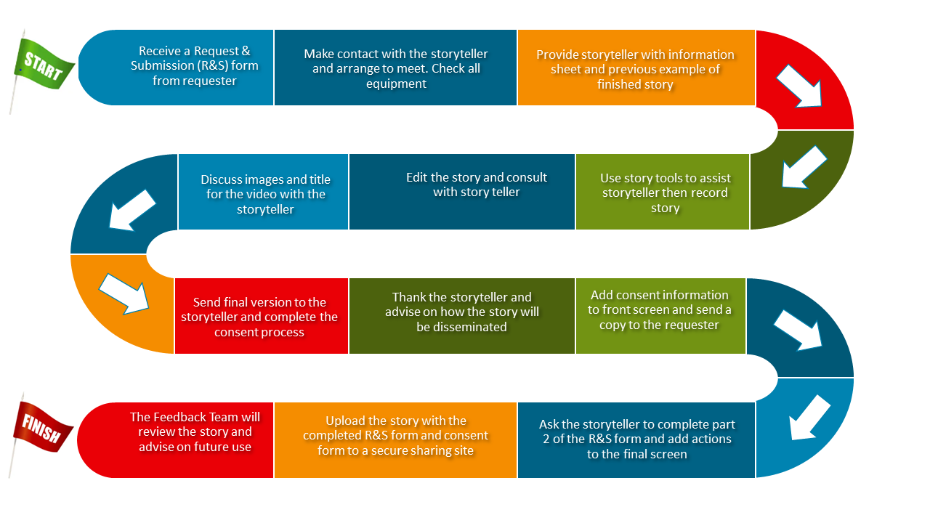

Storyteller information sheet
Thank you for taking the time to share your experience with SBU Health Board.
We want to hear about your personal experience (good and bad) so we can identify ways to continue to improve our services for our communities. This needs to be your story and any third person mentioned by name in the story needs to give their consent.
The story you share will be audio recorded and then, either transcribed or, put together with images (photographs or drawings of your choice) to create a short video clip.
You will not be filmed; you can remain as anonymous as you choose in your story.
Nothing will be shared with other people until you have reviewed the material and signed a consent form.
The story will not form part of your medical records and it will not affect any future care or engagement you or your family may have with us as your health care provider.
SBUHB will store your story safely and make it available for use in meetings and training sessions. You will be able to choose if the story is shared more widely on the internet. You may at any time ask us not to use or share your story further. Simply contact us using the details below and we will delete all your information to the best of our ability.
We know that sometimes people have experiences that are upsetting. If this has happened to you, or if telling your story is upsetting, the person recording the story will talk to you and, with your permission, they will arrange for someone to meet you and provide support.
Safeguarding and patient safety
Just occasionally, a person may tell us about something that might indicate they are in danger, or tell us about something that is dangerous in our services.
If we think you are in danger in any way we have a legal obligation to tell our Health Board Safeguarding Lead, who will then investigate to see if action should be taken, and whether they need to inform the statutory safeguarding authority.
If your story reveals that there is a situation that is unsafe or may put people in danger, we will take immediate action to make it safe. We will only reveal your story details as necessary to identify the issue and to take appropriate action.

If you have questions before or after your interview or you wish to withdraw consent at any time you can contact your patient experience manager:
Contact name: Position:

Phone: Email:

Storyteller consent form

I have understood the information contained within the Storyteller Information Sheet, a copy of which I have been given to keep. I agree to tell my story regarding my recent experience in the Health Service.
I understand my story will be digitally recorded and will be kept indefinitely.* The video will be used for service improvement. It will not form part of my medical records. I understand I can change my mind at any time without giving a reason, and this will not affect any future care that I or my relatives may need.

Please let us know your choices – please tick every box which applies:
I am willing for my story to be shared with:

Level 1: Health and Social Services professionals and quoted in Health Board leaflets

Level 2: Researchers for service evaluation and improvement beyond SBUHB

Level 3: Meetings & Conferences with anyone present including journalists
please note unless level 4 consent is given no recording will be made during online meetings

Level 4: Anyone including the Internet and Social Media
Please be aware that if it is published on the internet we cannot guarantee that all copies are deleted if you withdraw consent.

I have permission to use all the images I have provided Yes/No/Not Relevant
Title of my story:
The name I would like to be acknowledged by as the storyteller is:
Print Name: Date:
Signature: Contact details (email or phone):
Address:
Any further comments:
*Stories will be stored securely until it is clear that they are no longer being used in training etc. This will be reviewed every year by the patient experience team.
Thank you for agreeing to tell us your story.

Contact details for SBUHB representative
I have informed the above person about this interview, and I am sure they understand the content of both the Storyteller Information Sheet and this Storyteller Consent Form.
Name: Position:
Signature: E-mail:

Storyteller accessible consent form

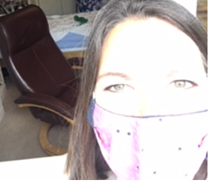 | Paula came to talk to me about the story we made.  Paula came to my house on 2/10/2020.  We had to talk through the window because of Covid 19.
 | Paula helped me tell my story about when I was in hospital with Covid 19.
 | We talked about computers.
 | I know that people will see my story on computers.
 | We talked about who will see the story.
 | I know that people who know me and people who don’t know me will see the story.
 | I told Paula that I don’t use face book (social media)
 | I told Paula that my story can go on face book (social media)
 | I told Paula that I think people will like to see my story.
 | I know that I can tell Paula if I don’t want the story to be used any more.
 | Paula e-mailed this form to me.
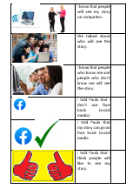 | Staff and I read the form together.
 | Paula, staff and I met on Teams.
 | Paula recorded the meeting and I signed the consent form.

Signed………………………………………………………………….. Date………………………………………

Guidelines for referring to patients in staff stories
NOTE: As a member of staff if you have any concerns about telling your story please speak to your corporate professional lead.
If a patient is mentioned in a staff story then
Either
The patient gives full consent for the story to be shown and completes a consent form.
This is the ideal situation.
Or
If there is no patient consent form, the following precautions should be taken:
The principle is that the patient should not be identifiable.
As a general rule there should be 11 or more patients that could have fitted the facts in the story and the impact on a patient who could be identified should be minimal.

The following things should be considered:
Use the member of staff’s first name only or no name
Don’t name the Service and Ward area
Patient – consider what details are needed – do you need name, age, gender or details of diagnosis or treatment? Keep references as general as possible for example “a male underwent a knee replacement operation and was experiencing pain the next day” would be acceptable.
If there is any doubt about the story then it should be sent to Information Governance for advice.
NOTE: These safeguards also apply to staff mentioned in stories by any storytellers

Action plan for digital stories

After completing a person’s story, it may be helpful to reflect on how well our values were embedded in practice surrounding the events that lead to the story. Please see the quality standards here.

Completion of the action plan may be helpful for planning how to meet areas where values were not best met. If appropriate, you may wish to use results from this activity when presenting a story to the Board, your Ward/Department or for identifying training needs or service improvements.

Name of person completing this Tool: *****

ACTION PLAN

Action Required | By When | By Whom | Expected  Outcome | Comments | Date Completed

It is important that if a change to service is identified, to note what measures will be in place to ensure, if applicable, it is sustainable and how this will be monitored.
Equally important is to consider follow up actions, including feeding back to the storyteller after their story has been completed.

Signature: Date:

Story graph & story board for helping people plan & shape stories
Widescreen Storyboard

Story Journey Graph
Plot the ups and downs of your story

START

Annotate with details of what happened and how it felt…. What was the turning point?
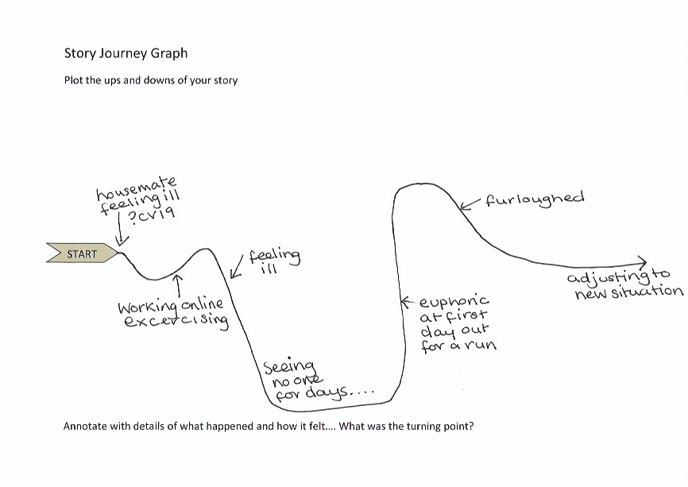
Story journey graph example

